A Mini Project Report
On

MediMate - An NLP-Based Digital Healthcare Consultation System

Submitted in partial fulfillment of the requirement of University of Mumbai for the Course

Natural Language Processing
In
Computer Engineering (VII SEM)

Submitted By
Amitesh Jain
Sanika Jayawant
Sobhasmita Mohapatra

Subject In charge
Prof. Harshada Sonkamble



Department Of Computer Engineering
A. P. SHAH INSTITUTE OF TECHNOLOGY THANE – 400 615
UNIVERSITY OF MUMBAI
Academic Year 2026 – 2027



CERTIFICATE
This is to certify that the requirements for the project report entitled ‘MediMate’ have been successfully completed by the following students:

Name Roll No.
Amitesh Jain 71
Sanika Jayawant 80
Sobhasmita Mohapatra 113
in partial fulfillment of the course Natural Language Processing in Computer Engineering (Sem VII) of Mumbai University in the Department of Computer Engineering, A. P. Shah Institute of Technology, Thane – 400 615 during the Academic Year 2026 – 2027.

Subject Incharge

Prof. Harshada Sonkamb

Abstract

In recent years, the growing reliance on digital healthcare solutions has underscored the need for reliable, accessible, and automated preliminary health advisory systems. However, generic conversational AI models frequently suffer from factual hallucinations, an inability to accurately handle medical negations, and an absence of transparent reasoning. To address these challenges, this project presents MediMate, an intelligent, natural language processing (NLP)–driven symptom analysis and healthcare recommendation system designed to emulate a digital pharmacist consultation. Unlike conventional unconstrained chatbots, MediMate implements a multi-stage, explainable NLP pipeline that processes unstructured, conversational user input prior to response generation. The core pipeline executes systematic text preprocessing, tokenization, lemmatization, body-part identification, and entity extraction to capture symptom duration and severity levels. Crucially, a rule-based negation detection algorithm differentiates between experienced and refuted symptoms (e.g., "I have a headache but no fever"), preventing false positives. Extracted clinical entities are mapped against a curated medical knowledge base and evaluated by an intent classifier featuring proactive red-flag emergency detection (e.g., severe chest pain or breathing difficulties). The resulting structured clinical context is subsequently passed to Groq’s high-throughput Large Language Model (LLM) API to formulate concise, grounded, and medically safe non-prescriptive remedy suggestions, supported by an offline fallback mode for seamless reliability. The system architecture combines a modular Python Flask backend with a responsive React (Vite) frontend, featuring a bento-grid dashboard, a live step-by-step NLP pipeline visualizer for clinical explainability, and browser-native speech synthesis for enhanced user accessibility. MediMate demonstrates that coupling deterministic NLP feature extraction with grounded generative intelligence effectively mitigates conversational hallucinations, providing an interpretable, secure, and user-centric platform for preliminary healthcare guidance.

CONTENTS

Sr. No. | Chapter Name | Page No.
1 | Introduction  - Background  - Objectives  - Scope | 1
2 | Literature Survey | 3
3 | Implementation Details  3.1 Overview  3.2 Implementation Details  3.3 Output Details and Screenshots | 4
4 | Conclusion  4.1 Conclusion  4.2 Future Scope | 13
5 | References | 14

Chapter 1

Introduction

  - Background

In the healthcare field, understanding symptoms and accessing reliable medical information are important challenges. Many people use online search engines and AI-based chatbots to understand their symptoms and seek basic healthcare guidance. However, general-purpose AI systems may provide inaccurate information, misunderstand medical descriptions, or fail to recognize important details such as negation. For example, a statement like “I have a sore throat but no fever” must not be interpreted as the presence of both symptoms.

To address these challenges, MediMate is developed as an NLP-based healthcare assistance system that helps users understand common symptoms and access relevant health information. It uses Natural Language Processing (NLP) techniques to process user queries, identify symptoms, detect negation, and extract details such as symptom duration, severity, and affected body parts. The system also identifies emergency warning signs and provides appropriate urgent-care guidance when critical symptoms are detected. To improve the reliability of its responses, MediMate combines a curated medical knowledge base with a Groq-powered Large Language Model (LLM). This approach helps generate relevant, understandable, and knowledge-grounded responses rather than relying entirely on unrestricted AI-generated information.

The major NLP processes used in MediMate include text preprocessing, tokenization, lemmatization, negation detection, clinical entity extraction, and intent classification. These processes help convert unstructured user queries into meaningful information that can be used to generate suitable responses. MediMate is designed as a supportive healthcare information tool and does not replace professional medical consultation or provide a confirmed medical diagnosis.

  - Objectives

The primary purpose of this project is to develop an explainable, safe, and intuitive digital pharmacist consultation system that overcomes the safety and reliability limitations of black-box conversational bots. The specific objectives of this project are as follows:

- To preprocess and normalize user queries using text cleaning, tokenization, and lemmatization techniques.
- To identify symptoms and extract relevant details such as severity, duration, and affected body parts.
- To implement negation detection to avoid incorrectly identifying absent symptoms as present.
- To detect emergency warning signs and provide appropriate urgent-care guidance.
- To integrate a medical knowledge base with a Groq-powered LLM to generate relevant and reliable healthcare information.
- To develop a user-friendly interface with interactive pipeline visualization and text-to-speech functionality.

  - Scope of the Project
The scope of MediMate includes basic symptom assessment, general healthcare information, home-remedy suggestions, over-the-counter (OTC) medicine information, and the identification of potential medical emergencies. The system processes natural-language queries and extracts relevant information to generate responses suited to the user's concerns.

MediMate combines rule-based NLP techniques with a medical knowledge base and an LLM to improve response relevance and safety. It also provides an interactive interface, pipeline visualization, and text-to-speech functionality to improve accessibility and user experience.

The project is intended for educational and informational purposes. It does not replace a qualified healthcare professional, prescribe medicines, or provide definitive medical diagnoses. Emergency-related queries require appropriate urgent medical attention. The system's reliability also depends on the quality of its medical knowledge base and the accuracy of its NLP processing. Future improvements may include multilingual support, expanded medical knowledge, and integration with electronic health records.

Chapter 2 Literature Survey
Sr. No. | Technique | Description | Author(s) and Year | Advantages and Disadvantages
1 | Rule-Based Negation Pattern Matching (NegEx) | Uses predefined rules and negation keywords to identify whether a medical symptom is present or absent in clinical text. | Wendy W. Chapman et al. (2001) | Advantages: Fast, interpretable, and requires no training data. Disadvantages: Struggles with informal language and complex sentence structures.
2 | Modular Clinical NLP Pipeline (cTAKES) | Processes clinical text to identify medical concepts, extract entities, and map them to standardized medical terminology. | Guergana K. Savova et al. (2010) | Advantages: Supports medical entity recognition and normalization.  Disadvantages: Computationally intensive and less suited to real-time informal conversations.
3 | Domain-Specific Transformer Representation (BioBERT) | Uses a biomedical language model trained on biomedical literature to understand medical context and recognize biomedical entities. | Jinhyuk Lee et al. (2020) | Advantages: Effective biomedical entity recognition and contextual understanding.  Disadvantages: May require significant computational resources and does not independently generate conversational responses.
4 | Clinical Triage and Benchmark Evaluation | Evaluates symptom-checking and triage systems for their ability to assess user-reported symptoms and recommend appropriate levels of care. | Ateev Mehrotra et al. (2015) | Advantages: Supports the evaluation of symptom assessment and triage.  Disadvantages: Structured triage approaches may struggle with complex, unstructured user descriptions.
5 | Knowledge-Grounded Conversational AI | Combines retrieved medical information with language models to generate responses grounded in relevant knowledge. | Eric Lehman et al. (2023) | Advantages: Can improve factual consistency and reduce unsupported responses. Disadvantages: Depends on the accuracy, coverage, and quality of the knowledge base.

Table 2.1: Comparative Analysis of the Research Papers based on existing NLP Techniques and Healthcare AI Systems

Chapter 3 Implementation
3.1) Overview
The primary purpose of an intelligent conversational health assistant is to decipher free-form clinical complaints, identify active pathological indicators, eliminate refuted conditions, assess urgency levels, and provide validated self-care recommendations. Achieving this reliably requires a dual-paradigm architecture: a deterministic Natural Language Processing (NLP) framework responsible for transparent entity extraction and safety gating, paired with a knowledge-grounded Large Language Model (LLM) for natural conversational synthesis. This section examines the operational limitations of conventional methodologies and details the proposed MediMate architecture designed to overcome them.

3.1.1 Existing Methodology and Systems
Existing digital healthcare consultation systems can be classified into three main categories:
- Keyword-Based Search and Retrieval Portals (e.g., WebMD, Healthline): These systems retrieve information based on matching keywords but often fail to understand context, symptom severity, duration, and negation. For example, they may treat “headache but no fever” as the presence of both symptoms.
- Rule-Based Decision-Tree Chatbots: These chatbots use predefined questions and decision paths to assess symptoms. Although predictable and structured, they offer limited flexibility and may struggle with natural conversations involving multiple symptoms.
- Unconstrained Generative LLMs (e.g., General-Purpose ChatGPT Implementations): These models generate fluent responses but may produce inaccurate medical information. Their limitations include:
  - Medical Hallucinations: Generating incorrect medical facts or drug information.
  - Negation Errors: Misinterpreting statements such as “patient denies nausea.”
  - Black-Box Reasoning: Making it difficult to verify how a response was generated.

3.1.2 Proposed Methodology and System
To resolve these critical vulnerabilities, the proposed system—MediMate—introduces a hybrid, transparent, and grounded clinical conversational architecture. Instead of directly transmitting raw user dialogue to an external generative model, MediMate processes user input through an independent, multi-tiered deterministic NLP pipeline.
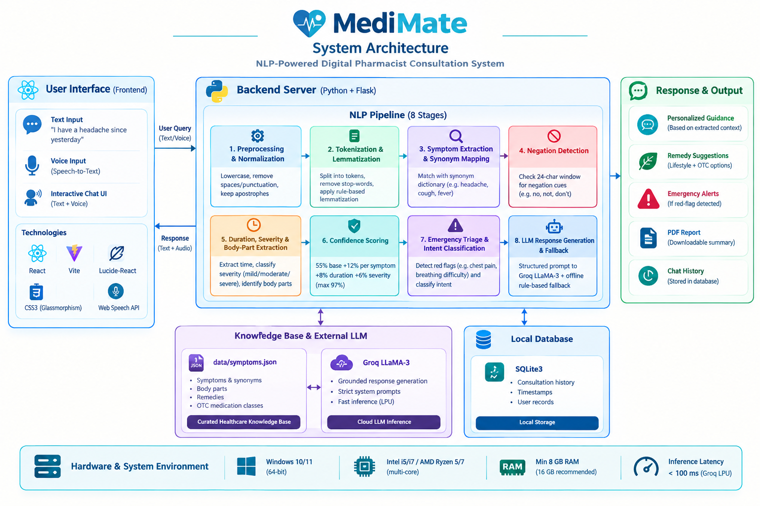

3.2) Implementation Details
3.2.1 Methodology
The MediMate NLP pipeline consists of eight sequential stages executed on the backend server:
1. Text Preprocessing and Normalization - User input is standardized by converting text to lowercase, removing extra spaces and unnecessary punctuation, and preserving apostrophes in contractions such as “don't” and “can't” for accurate negation detection.
2. Tokenization and Morphological Lemmatization - The cleaned text is divided into tokens using regular expressions. Common stop words are removed, and rule-based suffix stripping normalizes words, such as “coughing” to “cough” and “headaches” to “headache.”
3. Symptom Extraction and Synonym Mapping - Symptoms are identified by matching user input with synonyms in the local JSON knowledge base. For example, “my head hurts” and “throbbing pain in my head” are mapped to the standard symptom headache.
4. Window-Based Negation Detection - The system checks a 24-character window before each symptom for negation cues such as “no,” “not,” “without,” and “don't.” Negated symptoms are excluded from active symptoms and displayed with strikethrough formatting for transparency.
5. Duration, Severity, and Body-Part Extraction - Regular expressions identify duration expressions such as “for 2 days.” Symptoms are classified as mild, moderate, or severe, while anatomical terms such as head, throat, chest, and stomach are extracted.
6. Confidence Scoring Metric - The system calculates an extraction completeness score from 55% to 97%. It starts at 55%, adds 12% per active symptom, 8% for duration, and 6% for severity, with a maximum of 97%. This score reflects extracted information completeness, not the probability of a correct diagnosis.
7. Emergency Red-Flag Triage and Intent Classification - Queries are classified as greetings, symptom consultations, remedy inquiries, or emergencies. Critical cues such as chest pain, breathing difficulty, unconsciousness, and severe bleeding trigger urgent emergency guidance instead of routine home remedies.
8. Grounded LLM Response Generation and Offline Fallback - The extracted symptoms, negations, duration, severity, and verified knowledge-base information are passed to Groq LLaMA-3 through a structured prompt to generate concise, non-prescriptive responses. If the API or internet is unavailable, a local rule-based engine provides predefined responses, although its capabilities are limited compared with the online model.

3.2.2 Details of Packages, Dataset, and Tools
MediMate is developed using open-source technologies with separate backend and frontend components.
A. Dataset and Knowledge Base (data/symptoms.json)
The system uses a curated JSON database of common ailments, including headache, fever, sore throat, cough, common cold, stomach discomfort, muscle ache, and fatigue. Each record contains:
- label: Standard clinical name.
- synonyms: Common expressions used to describe symptoms.
- body_parts: Associated anatomical regions.
- remedies: Verified lifestyle and non-pharmacological remedies.
- otc: Relevant over-the-counter medication categories.
B. Backend Technologies and Packages (Python 3.10+)
- Flask (v3.0.3): Provides REST API endpoints for symptom analysis, consultation history, and PDF reports.
- Flask-CORS (v4.0.1): Enables communication between the frontend and backend.
- Python-Dotenv (v1.0.1): Loads environment variables securely.
- Requests (v2.32.3): Sends structured prompts to the Groq LLM API.
- FPDF2 (v2.7.9): Generates downloadable medical summary reports.
- SQLite3: Stores consultation history and timestamps locally.
C. Frontend Technologies and Packages
- React (v18.x) and Vite: Support component-based development, fast bundling, and reactive interfaces.
- Lucide-React: Provides icons for navigation, remedy cards, and analysis indicators.
- CSS3 and Glassmorphism: Create translucent cards, hover effects, and animated chemist-avatar interactions.
- Web Speech API: Enables browser-based voice input and text-to-speech responses.
D. Hardware and System Execution Environment
- Operating System: Windows 10/11 (64-bit).
- Processor: Intel Core i5/i7 or AMD Ryzen 5/7.
- Memory: Minimum 8 GB RAM; 16 GB recommended.
- Inference Performance: Groq cloud inference is used for fast LLM responses; actual latency depends on network conditions, model, and request size.
- Clarify the dataset's curation and safety boundaries.

3.3) Output Details and Screenshots
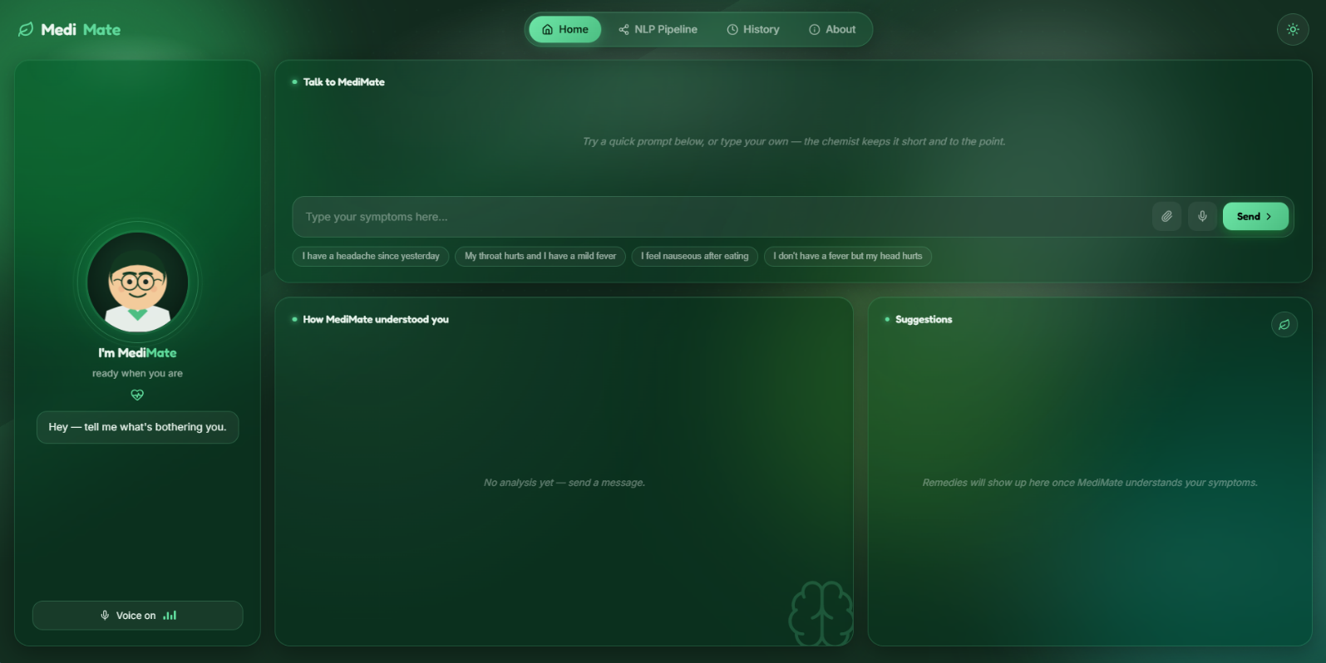
Fig 4.1: MediMate Home Consultation Dashboard with Animated Chemist Interface
The Figure 4.1 illustrates the primary consultation dashboard. The screen features a bento-grid layout containing the interactive animated chemist avatar. The chemist dynamically changes physical gestures depending on the patient's input, while speaking conversational advice aloud using the Web Speech API.

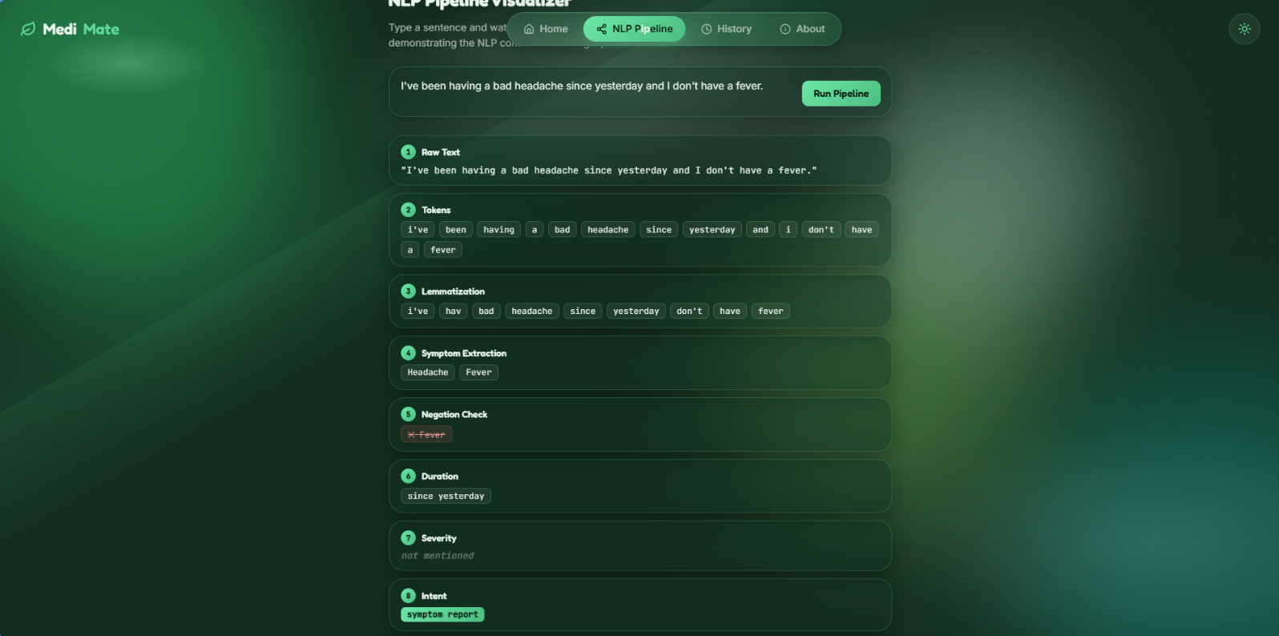
Fig 4.2: Real-Time NLP Pipeline Execution Trace and Entity Extraction Visualizer
The Figure 4.2 shows the transparent NLP Pipeline Visualizer panel. Developed specifically for academic explainability and clinical auditability, this panel reveals every intermediate computation: raw text cleaning, token segmentation, morphological lemmatization, active symptom identification, negated findings, duration/severity detection, and the calculated confidence index.

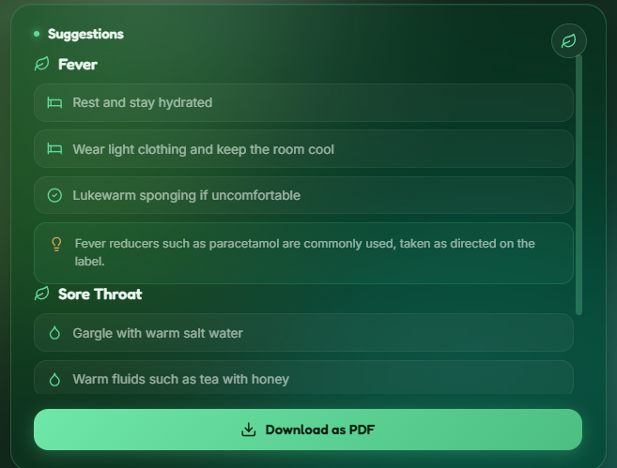
Fig 4.3: Structured Remedy, OTC Guidelines, and Escalation Threshold Cards
The Figure 4.3 showcases the structured recommendation cards generated from the curated knowledge base. To ensure patient safety, the advice is clearly categorized into non-pharmacological home care, over-the-counter medication awareness, warning signs, and specific clinical thresholds detailing when an in-person physician visit is required.

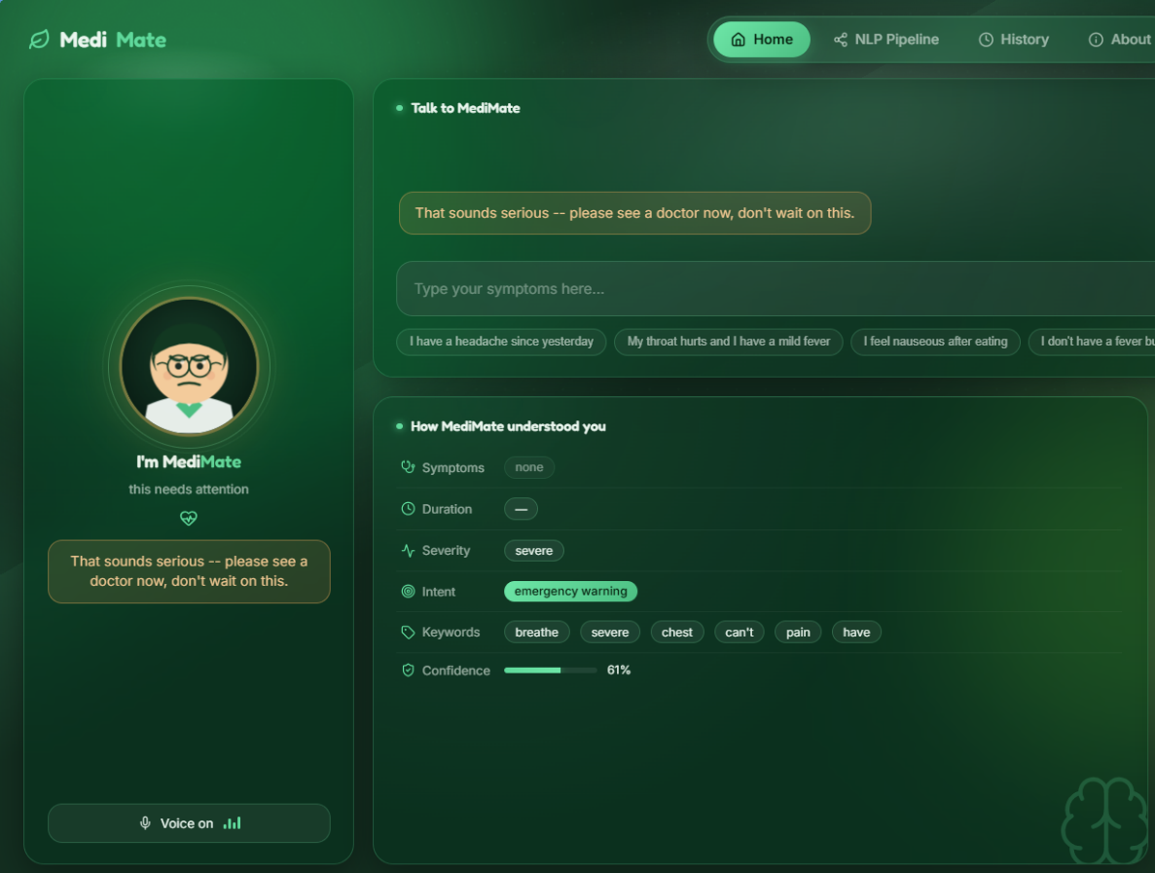
Fig 4.4: Emergency Red-Flag Triage Escalation Alert Screen
The Figure 4.4 illustrates the automated emergency safety screen triggered whenever a red-flag condition is identified. Standard home remedies are suppressed, and the user is directed to emergency medical care.

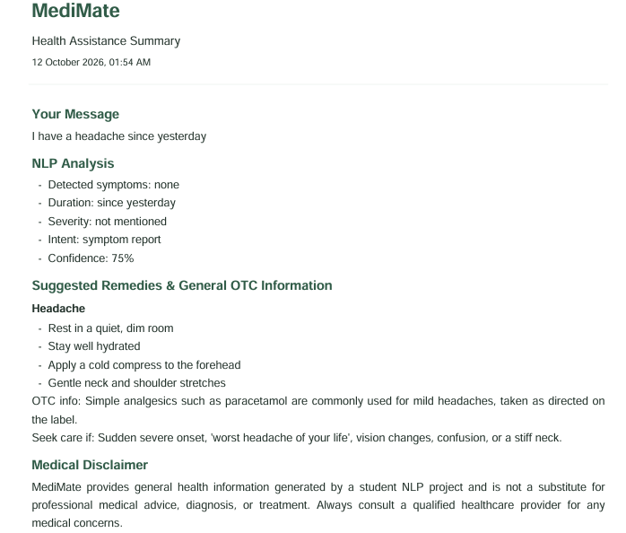
Fig 4.5: Consultation History Interface and Downloadable PDF Medical Report
The Figure 4.5 depicts the consultation history screen backed by SQLite persistence. Users can review past clinical consultations and download a formatted PDF summary generated by the backend fpdf2 service for their personal medical records.

Chapter 4

Conclusion
5.1) Conclusion
The development of MediMate, an NLP-driven digital pharmacist consultation system, addresses the limitations of conventional healthcare search tools and unconstrained generative AI systems. By integrating text preprocessing, tokenization, lemmatization, symptom extraction, negation detection, and severity assessment, the system converts user-described symptoms into structured information for preliminary health assistance.

MediMate further incorporates emergency red-flag detection, a curated healthcare knowledge base, and Groq LLaMA-3 for grounded response generation, along with an offline fallback mechanism. These features support safer and more accessible preliminary consultations while reducing the risk of misleading responses. However, MediMate is intended to provide general health guidance and preliminary triage, not to replace professional medical diagnosis or treatment.

5.2) Future Scope
1. Integration of Advanced Clinical Transformers: BioBERT and ClinicalBERT can improve symptom recognition and contextual understanding.
2. Multilingual Healthcare Support: Regional language and Hinglish support can make MediMate accessible to more users.
3. EHR Integration: HL7/FHIR integration can use medical histories, allergies, and existing conditions for personalized guidance.
4. Wearable IoT Integration: Wearable devices can provide real-time health data to support symptom assessment and risk identification.
5. Multimodal Computer Vision: Image analysis can enable preliminary screening of visible skin conditions, throat inflammation, and wounds.
6. Telemedicine and Appointment Routing: Integration with healthcare providers can help users find doctors and book consultations when needed.

References
References
[1] W. W. Chapman, W. Bridewell, P. Hanbury, G. F. Cooper, and B. G. Buchanan, “A simple algorithm for identifying negated findings and diseases in discharge summaries,” Journal of Biomedical Informatics, vol. 34, no. 5, pp. 301–310, Oct. 2001, doi: 10.1006/jbin.2001.1029.
[2] G. K. Savova, J. J. Masanz, P. V. Ogren, J. Zheng, S. Sohn, K. C. Kipper-Schuler, and C. G. Chute, “Mayo clinical Text Analysis and Knowledge Extraction System (cTAKES): Architecture, component evaluation and applications,” Journal of the American Medical Informatics Association, vol. 17, no. 5, pp. 507–513, Sep. 2010, doi: 10.1136/jamia.2009.001560.
[3] J. Lee, W. Yoon, S. Kim, D. Kim, S. Kim, C. H. So, and J. Kang, “BioBERT: A pre-trained biomedical language representation model for biomedical text mining,” Bioinformatics, vol. 36, no. 4, pp. 1234–1240, Feb. 2020, doi: 10.1093/bioinformatics/btz682.
[4] H. L. Semigran, J. A. Linder, C. Gidengil, and A. Mehrotra, “Evaluation of symptom checkers for self diagnosis and triage: Audit study,” The BMJ (British Medical Journal), vol. 351, p. h3480, Jul. 2015, doi: 10.1136/bmj.h3480.
[5] E. Lehman, V. Lialin, D. L. Leggetter, and A. Rumshisky, “Do we still need clinical language models? Grounding large language models for medical applications,” in Proceedings of the 2023 Conference on Empirical Methods in Natural Language Processing (EMNLP), Singapore, Dec. 2023, pp. 5812–5827.
[6] D. Jurafsky and J. H. Martin, Speech and Language Processing: An Introduction to Natural Language Processing, Computational Linguistics, and Speech Recognition, 3rd ed. draft, Prentice Hall, 2023.
[7] E. Loper and S. Bird, “NLTK: The Natural Language Toolkit,” in Proceedings of the ACL-02 Workshop on Effective Tools and Methodologies for Teaching Natural Language Processing and Computational Linguistics, Philadelphia, PA, USA, 2002, pp. 63–70.
[8] P. Lops, M. de Gemmis, and G. Semeraro, “Content-based recommender systems: State of the art and trends,” in Recommender Systems Handbook, F. Ricci, L. Rokach, B. Shapira, and P. B. Kantor, Eds. Boston, MA: Springer, 2011, pp. 73–105.

